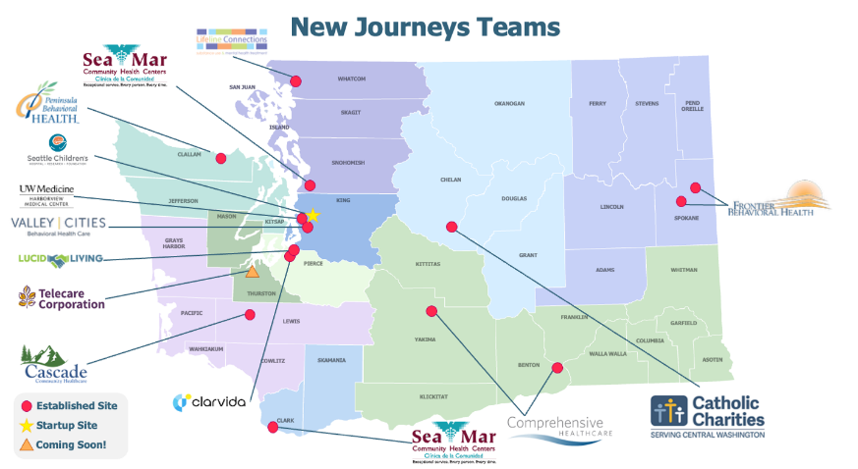
New Journeys is evidence-informed recovery-oriented outpatient care for individuals aged 15-40 who are experiencing new and unexpected changes in their perceptions and thinking, referred to as “first episode psychosis" (FEP).
There are teams across the state of Washington that offer comprehensive and personalized support.

Provides…
- Peer support
- Personalized therapy
- Help with medication decisions
- Employment and education support
- Symptom and stress management
- Support and education for families
Serves people…
- Age: 15-40 years old
- Location: Resident of a region where New Journeys services are available
- Symptoms: Psychotic symptoms have been present between 1 week and 2 years

When in doubt, reach out!
Visit www.newjourneyswashington.org to get more information and to contact our team
Or use the QR code below to submit a referral to New Journeys

